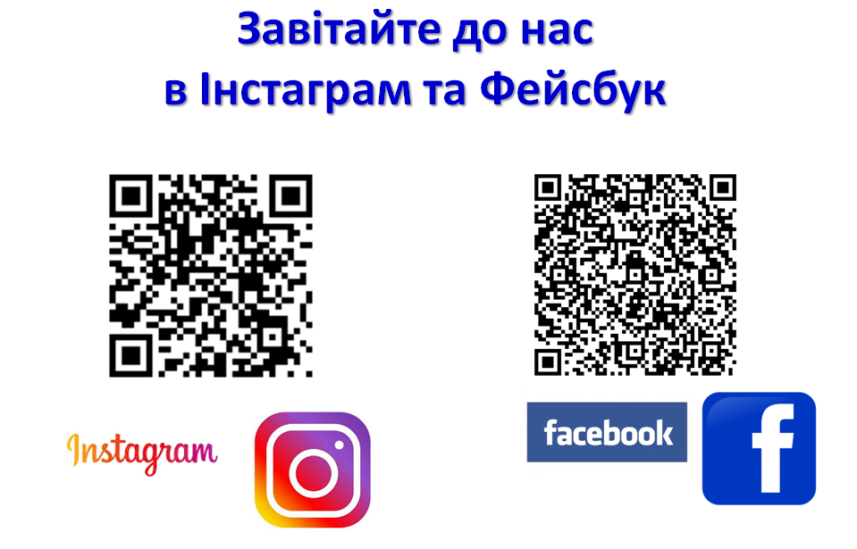
https://www.instagram.com/khvpu6/?igshid=eimbmi3ix17j | https://cutt.ly/wEsU0MF

